3.04-

Part 1-

Citation

Renoir, Pierre-Augusta (1876) Bal du moulin de la Galette. Retrieved from http://www.ibiblio.org/wm/paint/auth/renoir/moulin-galette/renoir.moulin-galette.jpg

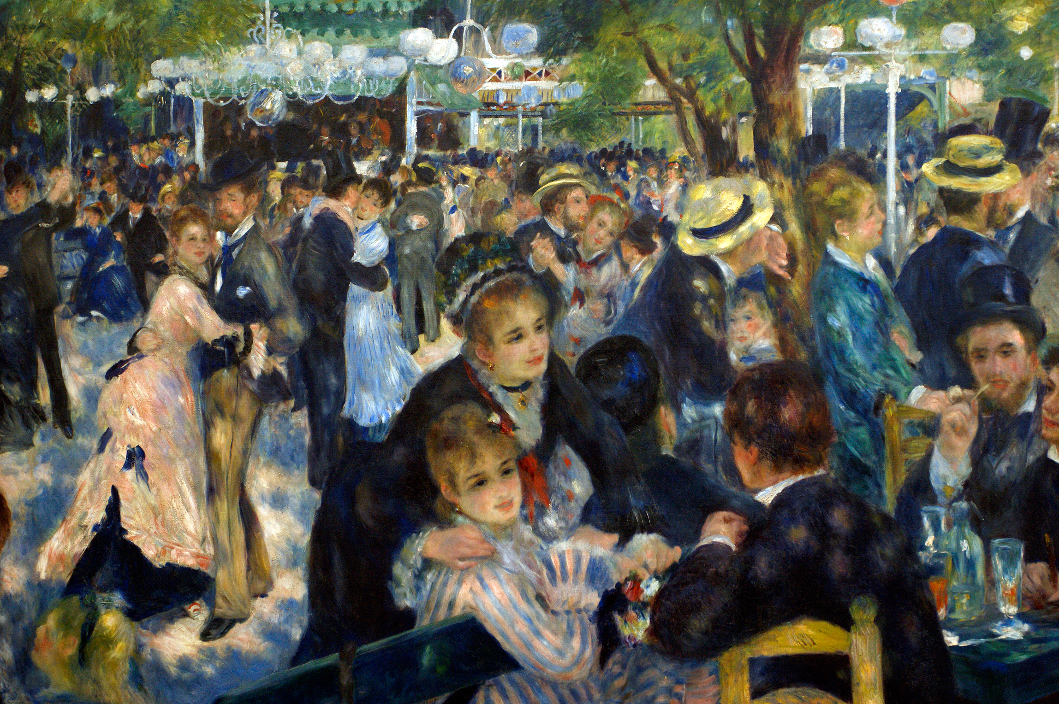

Pierre-Augusta Renoir’s Bal du molin de la Galette uses the monocular cues of relative size, interposition, and texture gradient. The chandeliers in the painting are rather small at the top of the painting. Renoir used relative size to give the viewer the feeling that the chandeliers are farther away than the women on the bench. Likewise, the women on the bench are painted larger than the people in the back, which also gives the feeling that the crowd in the back is farther away by using relative size. Renoir also uses interposition, or overlap, to portray which figures are closer and which are farther. This can be seen with the trees on the right side of the picture. The tree that appears closer is overlapping the tree that appears farther, giving the feeling that the first tree is closer than the second one. Texture gradient is the most predominant use of monocular cues in this painting. In the foreground, the couples that are dancing have detailed figures and seem to have a greater distance from each other. As the viewer continues to look at the painting, the crowd that is dancing gradually seems to compress together and the details are reduced while the figures become smaller, providing the viewer with the illusion of depth perception.

Part 2-

Citation

Dali, Salvador (1963) Cinquenta, Tigre Real. Retrieved from http://www.allposters.com/-sp/Cinquenta-Tigre-Real-Posters_i1214539_.htm

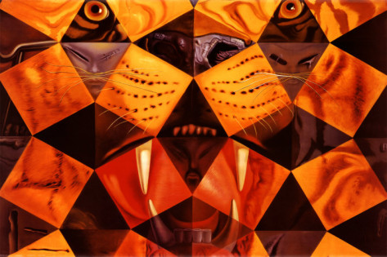

Cinquneta, Tigre Real by the famous artist Salvador Dali used the similarity, figure/ground, and closure Gestalt Principles of Organization. The use of similarity is used with the orange squares. Although the orange squares are spaced out they are still grouped together by the brain. The same goes for the darker diamonds, which although are far apart are grouped together. The figure/ground part of this painting is the face of the tiger in the image, which can be seen within the painting. Therefore, there are two images within the one, the tiger and the pattern of the diamonds and squares. Closure is also used is this painting as the mind outlines a face of a tiger. Although there is no outline present, the mind completes the figure on its own.

