Amino Acids Quiz
- The molecules in this figure are: 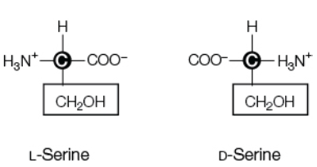

OPTICAL ISOMERS AND HYDROPHILIC
- An amino acid is considered both an acid and a base because it has an amino acid and a carboxyl function group, which are ionized by the addition or loss of
A HYDROGEN ION
- Peptide chains have an ____ and a ____ end
N TERMINUS; C TERMINUS
- A peptide linkage forms between
AN AMINO GROUP AND A CARBOXYL GROUP
- Leucine and valine have side chains that ___, and thus are ____
CONSIST ONLY OF C AND H; HYDROPHOBIC
- Aspartic acid and glutamic acid have side chains that _____, and thus are _____
ARE ACIDID, HYDROPHILIC
- All three of the amino acids shown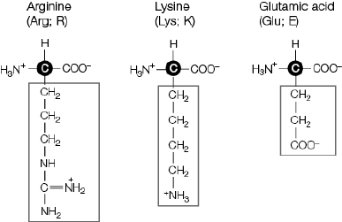
ARE HYDROPHILIC
- A disulfide bridge is formed by
TWO CYSTEINE SIDE CHAINS
- The amino acid that contains a weakly acidic “phenolic” group is
TYROSINE
- Which amino acids contain reactive aliphatic hydroxyl groups?
SERINE AND THREONINE

