Terms | Definitions | Application | Or Picture
- Stimulus | A reaction provoker | Reflex | Response
- Receptors | Stimulus-sensitive cells | Eye receptors | Ear receptors
- Central nervous system (CNS) | Nervous system containing brain and spinal cord | Two main structures | First part of nervous system
- Peripheral nervous system | Nervous system controlling everything outside brain and spinal cord | The rest of the nervous system | Second part of nervous system
- Somatic division | Part of PNS controls voluntary movement | Muscle movement | First part of PNS
- Neurons | Cells of nervous system | Communicator | Nervous system
- Sensory (afferent) neurons | Takes info from receptors to brain/spinal cord | Transporter | Message carrier
- Motor (efferent) neurons | Takes info from brain/spinal cord to muscles | Deliverer | Package
- Autonomic nervous system | Part of PNS controls involuntary internal actions | Internal organs | Second part of PNS
- Sympathetic nervous system | Part of ANS responsible for stressful situations | Fight or flight reponse | Alert center
- Parasympathetic nervous system | Part of ANS responsible for calming the body down | Paramedics | Stress-reliever
- Reflex | Automatic response without communication with brain | Instinctive action | Automatic response
- Lower level structures | Includes the medulla, pons, and cerebellum | The “hindbrain” | Back end of the brain
- Pons | Important for sleep and arousal | Relaxing pond | Calm
- Medulla | Responsible for breathing, swallowing, and blood circulation | 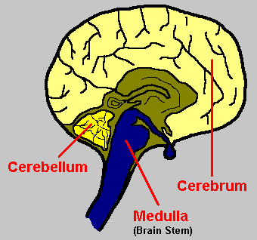
- Reticular formation | Nerve fibers responsible for arousal | 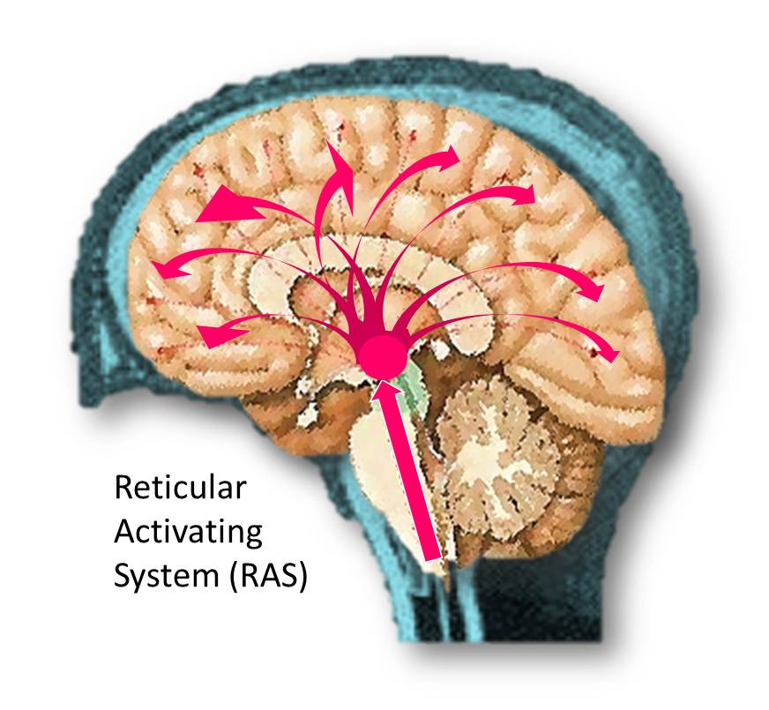
- Cerebellum | Coordinates voluntary muscle movements
- Corpus callosum | Neural fibers connects the cerebral hemispheres | Corpus Callosum is a Connector | Left-right interaction
- Limbic system | Structures under cortex responsible for emotion and learning | 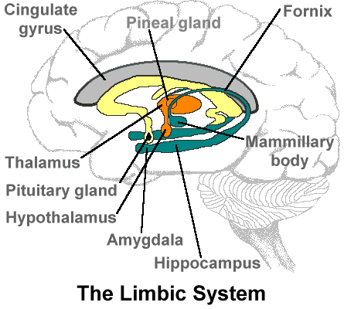
- Thalamus | Sends sensory information to cortex | Switch-board | Distributor
- EEG (electroencephalograph) | Records electric activity in brain | Epilepsy | Seizures
- PET scan (positron emission tomography) | Monitors metabolic activity in brain | Tracer | Radioactive sugar
- CT scan (computerized tomography) | Produces many X-rays which are then interpreted by a computer | 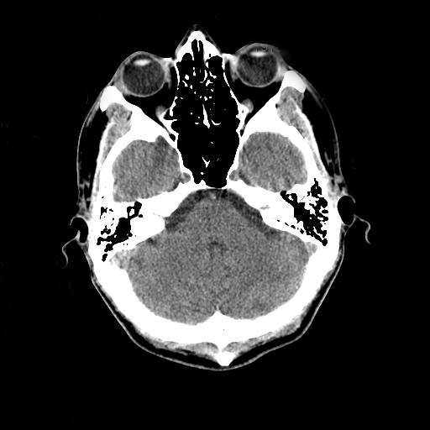
- MRI (magnetic resonance imaging) | Uses radio waves and magnetic field for detailed imaging | 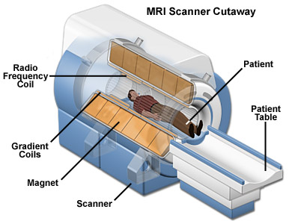
- Dendrites | Part of a neuron that receives information | Receiver | Satellite dish
- FMRI | Type of MRI allows structural and functional imaging | Detailed MRI | Live imaging
- Soma | Cell body of a neuron | 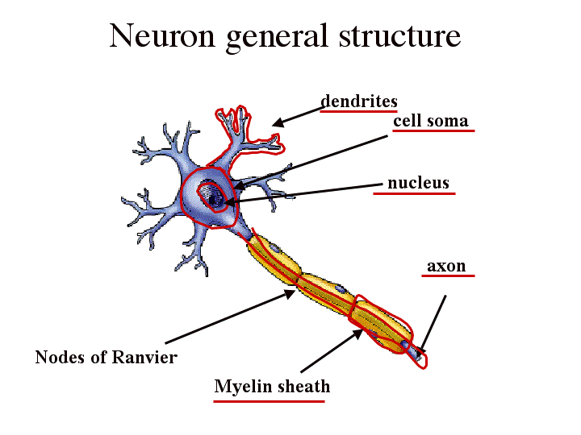
- Axon | Part of a neuron sends info to neurons and muscles/glands | Neuron Postal Service | Neuron communicator
- Myelin sheath | Fatty protein covers some axons and speeds up transmission | Protective case | Transmission booster
- Terminal buttons | Part of axon where neurotransmitters are stored | Storage site | Container
- Multiple sclerosis | Disease because of deterioration of myelin in the CNS | 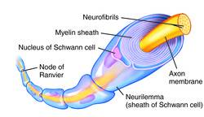
- Neurotransmitters | Chemical substances send info to neurons
- Synapse | Neuron interaction site | 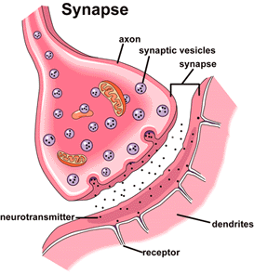
- Reuptake | Neurotransmitters are taken back into the terminal buttons | Suction | Vaccuum
- Synaptic vesicles | Sacs in terminal buttons contain a neurotransmitter | Locker | Storage cell
- Agonist | Enhances operation of neurotransmitter | Power boost | Modifier
- Antagonist | Blocks the operation of neurotransmitter | Road block | Bad guy
- Endorphins | Neurotransmitter aids in pain relief | Runner’s high | Pain
- Resting potential | Negative electrical charge neuron is not firing | Relaxing | Not working
- Action potential | Electrical charge travels down the axon | Depolarization | Working
- Threshold | Level of stimulation to start neural impulse | Capacity | Withstanding
- Refractory period | Neuron needs to repolarize before firing again | Boot up | Recover
- Aphasia | Loss of ability to speak or understand written or spoken language | Wernicke’s aphasia | Bronca’s aphasia
- Endocrine system | System of glands that produce and secrete hormones | Pituitary gland | Thyroid gland
- Hormones | Chemicals produced by glands and taken to other organs | Carried by bloodstream | Growth hormone
- Pituitary gland | Master gland. Controls other glands | Growth hormone | Controller
- Biological psychology | Branch of psychology deals with biology and behavior | Mind-body phenomenon | Behavior
- Acetylcholine | Neurotransmitter for muscle movement, learning, and memory | Lack of this results in Alzheimer’s disease | Muscle movement
- Dopamine | Neurotransmitter for movement, learning, and attention | Over activity linked with schizophrenia | Undersupply linked to Parkinson’s disease
- Serotonin | Neurotransmitter involved in mood, sleep, and appetite | Undersupply linked with depression | Released with exercise
- Norepinephrine | A neurotransmitter that controls alertness and arousal | Unddersupply depress mood | Selective attention
- GABA | A major inhibitory neurotransmitter | Inhibits movement | Involved with sleep
- Glutamate | A major excitatory neurotransmitter | Oversupply can result in migraines | Oversupply result in seizures
- Nerves | Neural "cables" containing many axons | Feeling | Pain
- Interneurons | Neurons that communicate with sensory and motor outputs | Most commonly found in brain | Head of neurons
- Lesion | Brain destruction | Deep lesioning | Abnormality
- Hippocampus | Limbic system structure responsible for memory | Memory | Hippo on Campus
- Hypothalamus | Limbic system structure responsible for maintenance activities | Body temperature | Hypo the Llamas
- Paul Boca | Discovered area on left frontal lobe responsible for spoken language | 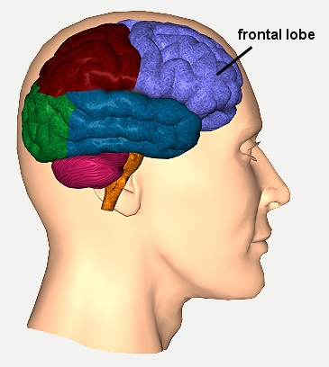
- Carl Wernicke | Discovered a brain area responsible for language comprehension | Wernicke’s area | Wernicke’s aphasia
- Depolarization | During action potential, neuron briefly becomes positive | Water molecule | Positive negative charges
- All-or-none principle | Neuron will only fire when threshold is reached | No more no less | Go or no go
- Amygdale | Responsible for fear memories and aggression | Fear | Russian MiG triggers fear
- Cerebral cortex | Wrinkly structure responsible for higher mental processing | 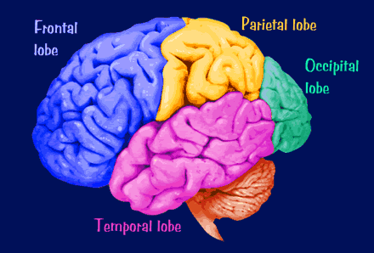
- Phineas Gage | Case study in which frontal lobes were severely damaged | No emotional control | Quick emotional changes
- Motor cortex | Responsible for voluntary movement on opposite side of body | 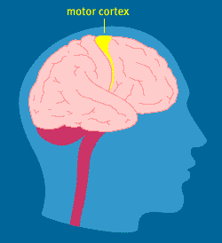
- Sensory cortex | Processes sensory information from opposite side of body | 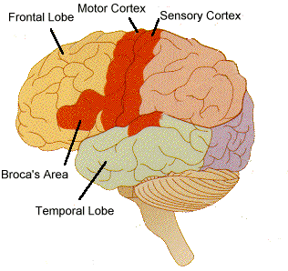
- Angular gyros | Transfers written language into auditory info | 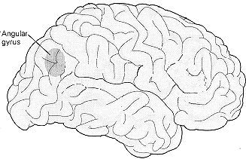
- Occipital lobe | Contains visual cortex for sight | Eyes | Back of the brain
- Temporal lobe | Contains auditory cortex for hearing | Ears | Near temples
- Roger Sperry & Michael Gazzaniga | Studied split brain patients | No corpus callosum | Left not connected to right
- Phrenology | Study of the shape and size of the brain | 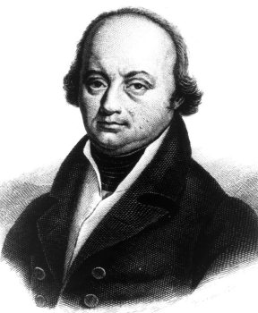
- Franz Gall | Developed phrenology | Brain structures | Brain size
- Gray matter | Outer layer of cortex | “Skin” | Cover
- White matter | Inner layer of the cortex | “Flesh” | Inside
- Broca’s area | Involved with muscle movements for speech | Left frontal lobe | Speech
- Wernicke's area | Brain area involved in language comprehension | Left temporal lobe | Comprehension
- Association areas | Areas of the cerebral cortex involved in higher mental processes | Bronca’s area | Wernicke’s area
- Neuroplasticity | Ability for brain to reorganize in response to injury | Adaptation | Rebuild
- Traumatic Brain Injury (TBI) | Serious head injury that damages brain | Concussion | Brain damage

Sources (for pictures)-

http://image1.findagrave.com/photos/2008/110/7773_120870652743.jpg

http://www.shaktitechnology.com/Angular_Gyrus.jpg

http://www.cerebromente.org.br/n07/doencas/brainmap2.gif

http://morphonix.com/software/education/science/brain/game/specimens/images/cerebral_cortex_lobes.gif

http://www.neuroskills.com/images/frontlobe11.jpg

http://scienceblogs.com/purepedantry/wp-content/blogs.dir/454/files/2012/04/i-43a5bc26d35649e7cc2aeaeb17f3938f-synapse.gif

http://howtoimporttoaustralia.com.au/wp-content/uploads/image/Cross%20out.png

http://img.tfd.com/MosbyMD/thumb/myelin_sheath.jpg

http://www.liverez.com/blog/wp-content/uploads/2012/12/Email-Automation1.jpg

http://www.ucl.ac.uk/~sjjgsca/NerveNeuronDiag.gif

http://www.magnet.fsu.edu/education/tutorials/magnetacademy/mri/images/mri-scanner.jpg

http://upload.wikimedia.org/wikipedia/commons/d/da/Head_CT_scan.jpg

http://antorjatikbangali.files.wordpress.com/2012/01/limbic.gif

http://stopsellingvanillaicecream.com/wp-content/uploads/2013/06/Balance.jpg

http://occlusionconnections.com/Blog/wp-content/uploads/2011/03/RAS-Occlusion-Connections.jpg

http://www.myschoolhouse.com/courses/c/3/Images/brain.gif

